**OSEB EDUCATIONAL CONSULT**

 **LOCATED 6 MILES GAYAZA ROAD-KAMPALA**

**CONTACT: 0742845900/0775787978**

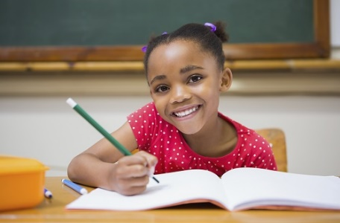

**HOLIDAY PACKAGES**

**ARE READY!!**

**P.3**

**Topical questions**

**NOTE: WE GIVE BOTH HARD COPIES AND SOFT COPIES**

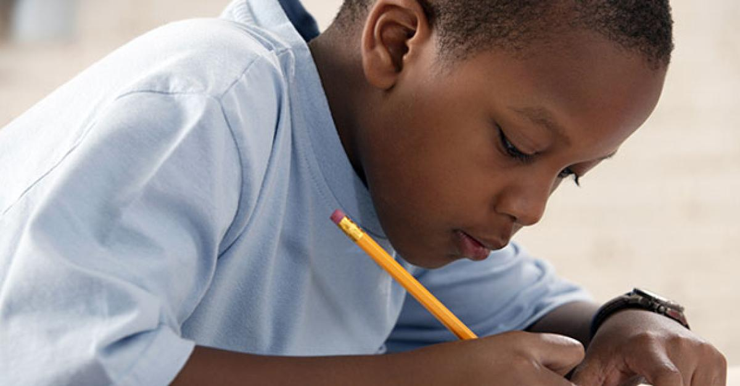**OTHER SERVICES OFFERED**

**LESSON NOTES AND THEIR**

**SCHEMES OF WORK**

**EXAMS (B.O.T, MIDs, &**

**END OF TERM)**

**BOOK COVERS (ALL SIZES)**

**TOPICAL QUESTIONS**

**Your success is our target**

**OUTREACH EXAMINATION BOARD**

**PRIMARY THREE MATHEMATICS**

**SPECIAL PACKAGE ONE**

**Name:………………………………………………… Stream:…………………**

**Lesson 1**

**TOPIC: PLACE VALUES.**

**SUB TOPIC: Writing numbers from the abacus.**

**Examples**

2

4

1

=

241

O

T

H

4

1

2

=

4012

O

T

H

TH

0

1. 2.

**Exercise**

=

______

O

T

H

=

____

O

T

H

1. 2.

=

______

O

T

H

=

________

O

T

H

TH

3. 4.

=

_______

O

T

H

TH

=

_______

O

T

H

TH

5. 6.

**LESSON II**

**TOPIC: PLACE VALUES**

**SUB TOPIC:Showing numbers on the abacus**

**Examples**

2

5

3

=

205341

O

T

H

TH

0

1. **2.**

1

4

5

=

1245

O

T

H

TH

2

**Activity**

**Now I can try the following on the abacus.**

=

4202

O

T

H

TH

=

1222

O

T

H

TH

1. **2.**

=

3621

O

T

H

TH

=

1006

O

T

H

TH

**3. 4.**

=

3402

O

T

H

TH

=

1421

O

T

H

TH

**5. 6.**

**Lesson 3**

**Topic: Addition**

**Note:** Always add starting with ones

**Examples**

1. T O add ones = 1+2 = 3

1 1 add tens = 1+1 = 2

+ 1 2

2 3

2. 2 4 add ones = 4+3 = 7

+ 1 3 add tens = 2+1 = 3

3 7

**Activity**

**Now I can try the following**

1. 2 1 2. 2 2

+ 1 5 + 2 0

**3.** 2 3 4. 3 0

+ 3 3 + 3 2

5. 3 7 6. 3 6

+ 2 2 + 2 1

7. 3 6 8. 2 4

+ 3 0 + 1 3

**Lesson 4**

**Topic:Addition**

**Sub topic: Word statements involving addition**

**Note:** First read and answer questions about addition

**Examples**

1. Ashabe had 32 mangoes. She picked 17 more mangoes. How many mangoes did she have altogether?

Ashaba had 3 2 Mangoes

She picked + 1 7 Mangoes

**Altogether = 4 9 Mangoes**

1. Wamanga made 24 pancakes. His friend gave him 30 more pancakes. How many pancakes did he have?

Wamanga made 2 4 pancakes

He was given + 3 0 pancakes

**He had 5 4 pancakes altogether**

**Activity**

**Now let us try these numbers**

1. Acen picked 40 guavas and Akello picked 37. How many guavas did they pick altogether?
2. Rukandonda took 51 cows to graze. Kalanzi took 35 cows. How many cows did the two boys graze altogether?
3. Kato collected 32 bottle tops and Babirye collected 37. How many bottle tops did they collect altogether?
4. Mabale had 38 eggs. Nambozo had 41 eggs. How many eggs did they have altogether?

